- Jo buys a notebook computer which has a 3MHz quad-core central processing unit (CPU).
  - State the purpose of the CPU. (1)
  - Describe what is meant by
    - 3MHz CPU. (2)
    - Quad-core CPU. (2)
- A desk-top computer’s memory includes ROM and RAM.
Tick one box in each row to show whether each of the statements is true for ROM or RAM. (3)
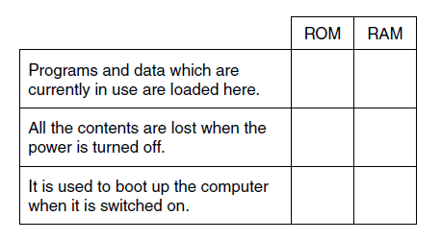
- A shopping centre uses several remote-controlled CCTV cameras for security. An operator uses a computer to watch, control and record the output of the cameras. State (a) an input, (b) output and (c) storage device which will be needed by the computer. For each, explain the reason why it is needed. (6)
- Mina’s computer has 4GB of RAM.
  - Describe the purpose of RAM in the computer. (2)
  - The computer also uses virtual memory.
    - Explain what is meant by virtual memory. (2)
    - State why virtual memory is needed. (1)
    - Mina upgrades the computer to 6GB of RAM. Explain how this upgrade will affect the performance of the computer. (2)

  - The following logic circuit can be written as P = (NOT A) AND B
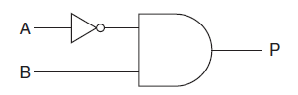
Complete the following truth table for the circuit given above. (3)
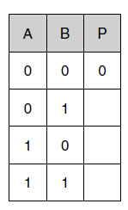
  - Draw the circuit diagram which will represent the circuit P = NOT (A AND B) (2)

  - State what is meant by a storage device, an input device and an output device in a computer system. (3)
  - A secondary school is upgrading its computer equipment. Complete the table below to show whether magnetic, optical or solid state storage is most appropriate for each of the following uses. Give a reason for each case. The first one has been done for you. (6)
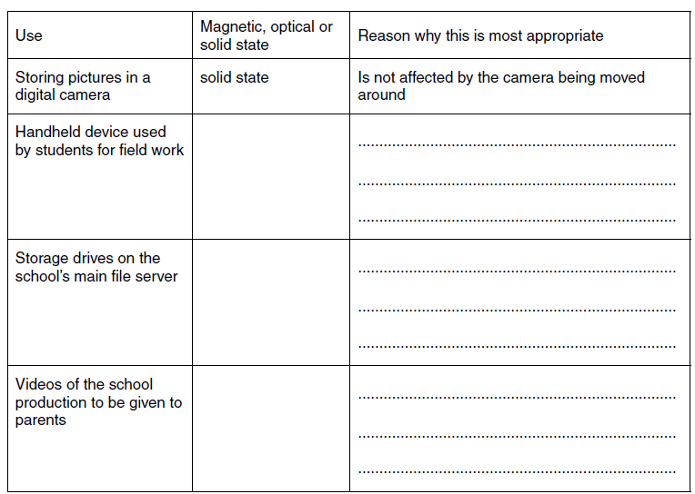
  - The secondary school wants the computer systems to be more accessible to students with disabilities. Describe, with examples, input and output devices which are available for students with disabilities. (6)
- Mary’s computer has an 800MHz CPU and 1GB of RAM.
  - Describe the purpose of the CPU. (2)
  - Mary wants to upgrade this computer so that she can play the latest games. Explain two ways by which the computer can be upgraded to improve its performance. (4)
- The following logic circuit can be written as P = NOT (A and B)
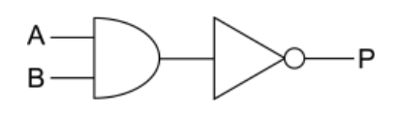
  - State the output (P) of the circuit if the inputs are:
    - A = 1, B = 0 (1)
    - A = 1, B = 1 (1)
  - Draw the logic circuit for P = (A OR B) AND C (2)

  - The table below contains statements about the functions of the CPU. Tick one box in each row to show whether the statement is true or false. (4)
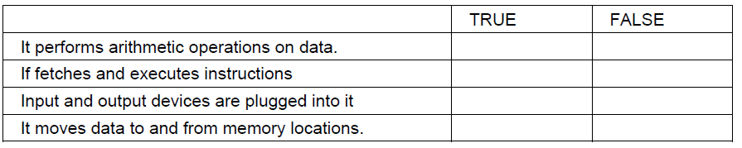
  - Some CPUs have cache memory.
    - Describe what is meant by cache memory. (2)
    - Explain why cache memory is needed. (2)
- Here are some statements about the CPU of a computer.
Tick one box in each row to show whether each of the following statements is true or false. (5)
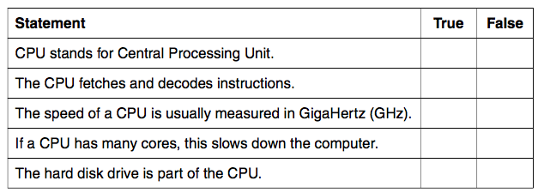
- Bob’s computer has 512 kilobytes of ROM and 8 gigabytes of RAM.

    - Describe the purpose of the ROM in Bob’s computer. (2)
    - Describe the purpose of the RAM in Bob’s computer. (2)
  - State one difference between ROM and RAM, other than the size and the purpose. (1)

    - State the purpose of an input device in a computer system. (1)
    - State the purpose of an output device in a computer system. (1)
  - A railway company uses a computer terminal in the train station to sell train tickets.
Customers input their destination using a touch screen, pay by card and receive a printed ticket and receipt.
Describe two ways that the hardware in the computer terminal can be adapted so that blind customers can use it. (4)

- Apu has a handheld e-book reader that allows him to store and read electronic books.
  - State one input and one output device that can be built into the e-book reader to allow users to read books. (2)
  - Types of secondary storage devices are magnetic, optical or solid state.
    - State which type of storage is most suitable for storing the electronic books inside the e-book reader. (1)
    - Explain one reason why this type of storage is the most suitable (2)
  - Apu gets a free e-book on a CD-ROM from a magazine.
    - Give two reasons why a CD-ROM is suitable in this case (2)
    - State whether a CD-ROM is magnetic, optical or solid state storage (1)
- A typical smart phone is a computer system with input, output and storage devices.
State one input device, one output device and one secondary storage device that are built into a smart phone. (3)

- The table below contains a list of hardware devices. Tick one box in each row to show what type of device it is. The first one has been done for you. (4)
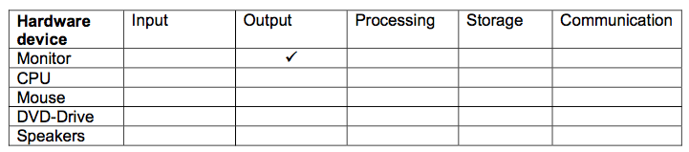

- Dipesh is thinking of buying a tablet computer to replace his old desktop computer.
  - Describe how the CPU and RAM work together to enable the tablet computer to operate. (3)
  - The tablet computer also uses cache memory. Describe the purpose of cache memory. (2)
  - Describe how the advances in memory technology have allowed significant improvement in
the performance of devices such as tablet computers. (6)

