- A teacher uses a database to store the marks of pupils from all year 9 classes.
  - PUPIL and CLASS are two entities used in this database.
Explain the term entity.
  - The data for the first four pupils in the PUPIL table is shown below.
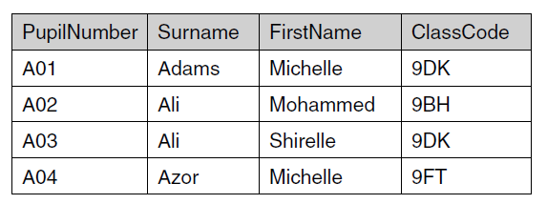
    - State the primary key for the PUPIL table and explain your answer.
    - The database also contains a CLASS table. The primary key for the CLASS table is ClassCode. Explain why ClassCode has also been included in the PUPIL table.
- A grocery shop uses a database with a DBMS to keep records of its stock.
  - Explain what is meant by a DBMS.
  - The database uses forms and reports.
Describe each of these and give one example of how it would be used in the shop’s database.
  - Here is some data from the supermarket’s database.
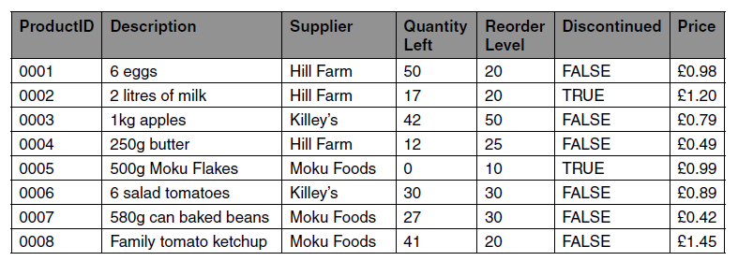
    - State the ProductID of the products in the above sample which fit the following criteria.
Supplier = Killey’s
    - State the ProductID of the products in the above sample which fit the following criteria.
Price > £1.00 OR Supplier = Hill Farm
    - Write the criteria which can be used to select all products which are not discontinued and where the QuantityLeft is lower than the ReorderLevel.
- Mrs Smith runs a dog sitting service that looks after dogs whose owners are going away on holiday.
Mrs Smith uses a database with two tables:
• The table DOG stores the following data about each dog: DogID, name, sex, weight, date of arrival, date of departure.
• The table JOB stores the daily jobs that she needs to do with each dog.
  - The DOG table contains fields for the sex and weight of the dog.
    - Describe a validation check that can be done on the sex field.
    - Describe a different validation check that can be done on the weight field.
  - An extract of the JOB table is shown below:
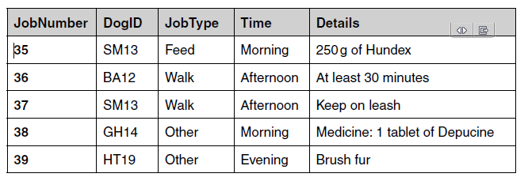
Explain why DogID has been included in this table.
  - Mrs Smith uses a query to select jobs using the following criteria:
(Time = “Afternoon”) OR (Time = “Evening”)
List the JobNumbers of the jobs that will be selected from the extract shown.
  - Mrs Smith wants to use database management software to create a report of all the jobs that she needs to perform on any given day, using data from the DOG and JOB tables.
Design a layout for the report.
- A dentist uses a database to store the details of patients and their appointments.
  - A database management system (DBMS) is used which includes forms, queries and reports.
Tick one box in each row to show whether each of the following statements best describes a form, a query or a report.
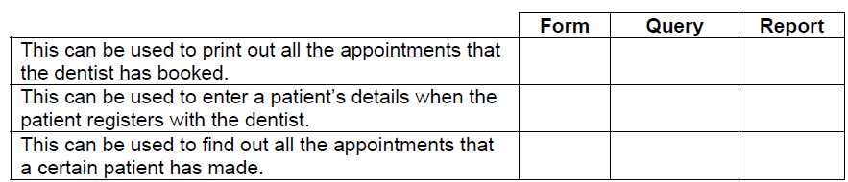
  - When a patient makes an appointment, the start time of the appointment needs to be validated.
State two validation checks which can be carried out on the start time of an appointment.
  - Justify the use of separate entities to store the patient and appointment data.
- A television set top box contains a database of television channels and programmes.
  - Describe what is meant by a database.
  - Data about television channels are stored in the CHANNEL table. Part of this table is shown below.
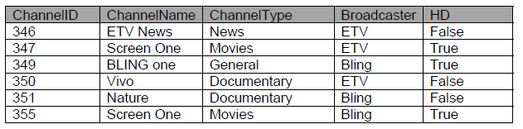
State the primary key for the CHANNEL table and give a reason for your choice.
  - Data about programmes that will be broadcast are stored in the PROGRAMME table. The data about each programme includes the channel on which it would be broadcast.
    - Explain how a foreign key can be used to connect the PROGRAMME table to the CHANNEL table.
    - Explain why the programme data is stored in a separate table from the channel data.

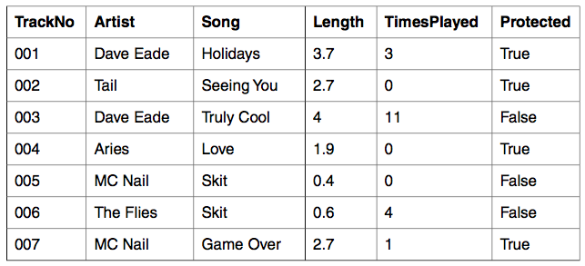
- An MP3 player contains a database of songs. This database has only one table. A sample of the data in this table is shown below.
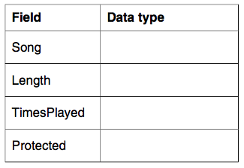
  - State the most appropriate data type for each of the fields shown below.
  - The mp3 player allows users to create playlists by using queries. For example if the query used is
Artist = “Dave Eade”
the mp3 player will play tracks number 001 and 003.
    - State the TrackNo of the songs that will be played using each of the following queries.
Length > 2
(Artist = “MC Nail”) OR (Protected = False)
(Song = “Skit”) AND (TimesPlayed > 0)
    - Write down the query that will select all songs over 2.5 minutes, which have never been played.
    - The mp3 player can be connected to a computer from which songs can be added. The computer has a relational database with many tables. Explain, using an example, what is meant by an entity and how entities relate to the tables.
- A school uses a database, which stores the attendance data of the pupils. The data is entered by teachers using a desktop data application and accessed by parents using a web page or mobile phone application.
  - Define the term database.
  - Explain one benefit of separating the data from the applications that use the school’s attendance database.
  - The school uses a database management system (DBMS) to separate the data from the applications that use it. Describe one example of how each of the following features of a DBMS can be used in the school’s attendance database.
    - The ability to run queries
    - The ability to set validation rules

- A hairdresser uses a relational database to keep records of his clients and their appointments. The hairdresser uses off-the-shelf data-handling software to manage the database.
  - State what is meant by off-the-shelf software.
  - Describe how the data-handling software can be used to set up the structure of the database, before any data is added.
  - State two tasks the hairdresser can perform using the data-handling software, once the database is in use.

