- A small business has three stand-alone computers, a printer and an internet connection in an office.
  - State two advantages of connecting the computers to create a local area network.
  - Describe, using a diagram, how the computers can be connected to each other using a bus topology, stating what hardware will be needed.

  - Tick one box in each row to show whether each statement is true or false.
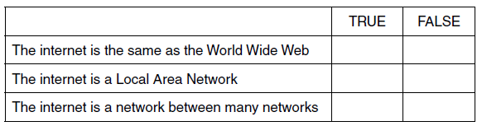
  - A user types the address www.ocr.org.uk into a web browser. Describe how a DNS server is used to access this website and explain the advantages of using DNS servers.
The quality of written communication will be assessed in your answer to this question.
- A rock band uses an internet website to advertise its music.
  - The website uses HTML.
    - Describe HTML.
    - Explain the importance of HTML in the creation of web pages.
  - A list of file extensions for common file standards used on the internet is shown below.
JPG PDF MP3 MPEG ZIP
The rock band allows some files to be downloaded by fans. Complete the table below to show which file format from the list given above may be used for each of the following files.
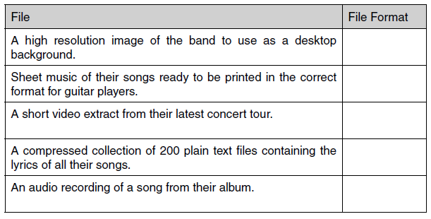
  - Some of the file formats use compression.
    - Explain the importance of compressing files when transmitting them via the internet.
    - Describe the difference between lossy and lossless compression and give an example where each would be used.
- A large company with 200 employees uses a local area network (LAN) which includes all the computers in its head office.
Describe the security measures and network policies which can be used to safeguard the security and privacy of the company’s data on the network.
The quality of written communication will be assessed in your answer to this question.
- A classroom in a primary school has 6 standalone computers. The school decides to connect them to form a LAN.
  - What is a LAN?
  - State two advantages of connecting the computers into a LAN.
  - The school decides to use the star topology to create the LAN.
Describe what is meant by a star topology. You may use a diagram.
  - Explain, with reasons, what additional hardware will be required to connect the computers into a LAN.
- A city has many libraries. Each library has several computers.
  - All the computers in a library are connected to each other through a local area network (LAN) and the libraries are connected through a wide area network (WAN).
Tick one box in each row in the table below, to show whether the statements given below are true for the LAN only or for both LAN and WAN.
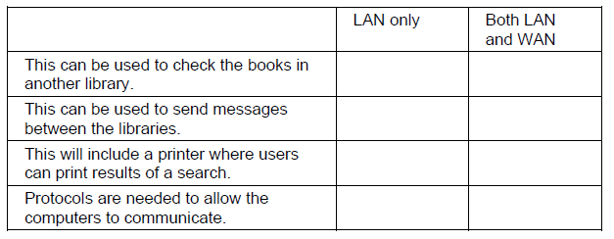
  - Some computers are available for public use.
Explain why the libraries need the following security measures:
    - User access levels
    - Firewalls

