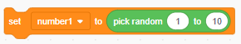
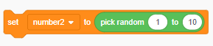
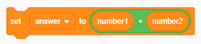
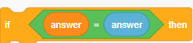
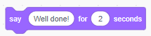
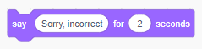

Start
Set number1 (random number)
Set number2 (random number)
Work out number1 + number2
Print the question
If the answer is correct
Print “Well done!”
Otherwise
Print “Incorrect”

import random
number1 = random.randint(1,10)
number2 = random.randint(1,10)
answer = number1 + number2
guess = int(input(“What is ” + str(number1) + “ + ” + str(number2) + “? ”))
if guess == answer:
print(“Well done!”)
else:
print(“Incorrect”)

