  - An error in the rules/grammar of the language with any suitable example.
  - Error messages/translator diagnostics produced when translating/by the compiler or on the fly while writing code. Attempts to tell you what the error is and indicate where the error is/line numbers/underlines. Editor allows you to enter the corrected code.

  - 0, 12, 4.
  - Set of test data: 1 1 3 / 1 1 4 / 1 1 5 / 1 1 6 / 2 2 5 / 2 2 6
Expected output: -1 -2 -3 -4 -1 -2
  - A data structure/collection of several variables under one name. Each individual variable is given an index by which it is referred within the array.
  - Data type: Integer. Reason: A dice roll is always a whole number between 1 and 6.
Size: 3. Reason: one element is needed for each dice.
  - Example (also accept similar with FOR-NEXT loop)
BEGIN RollTheDice
i = 1
WHILE i <= 3
DiceRoll(i) = Random No
i = i + 1
END WHILE
END

    - A name/symbol which represents a value is a program. The value can change while the program is running.
    - ORIGIN
String. Consists of more than one character.
Size
Integer. Consists of whole numbers.
  - Dress A : 14
Dress B : 10
Dress C : 12

  - Coins(4)=50, Coins(10)=0.

    - The program is written to do something other than what the programmer intended
    - It will only reset the first 9 elements / will not reset the 10th element. After setting Coins(9) = 0, i will become10 and the loop will stop. It should be UNTIL i > 10 / or other working correction
  - Example:
i = 1
total = 0
REPEAT
total = total + Coins(i)
i = i + 1
UNTIL i>10 or Coins(i)=0
OR:
total = 0
FOR i = 1 to 10
total = total + Coins(i)
NEXT i

    - Pi
    - WheelSize & Circumference
    - The value of a constant cannot be changed once the program is running (can only be set at design time). The value of a variable can change as the programming is running and has no value at design time.
  - An integer is a whole number. A real number can include decimal fractions.
- Example:
BEGIN
Input RealAge
IF RealAge <= 2
DogYears = RealAge * 12
ELSE
ExtraYears = RealAge – 2
DogYears = 24 + ExtraYears * 6
END IF
END

  - A name which is used to identify a memory location used to store a value which can change.

    - A=4, B=9
    - A=2, B=2
  - Example:
If A > B Then
Temp = A
A = B
B = Temp
End If

  - Message: String
Number of flashes: Integer
  - 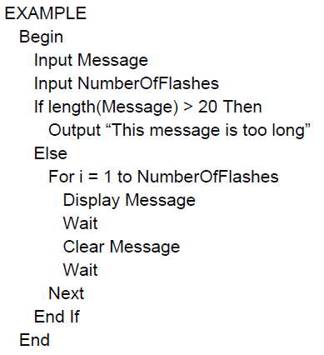

  - Network: string/text/alphanumeric
CallLength: real /float/single/double
SameNetwork: Boolean
TotalCalls: integer
RunningCost :currency/real

    - TotalCalls=11
RunningCosts=12.01
    - TotalCalls=12
RunningCosts=12.51

  - The keyword AND has been misspelled (ADN). This breaks the rules of the language and is a syntax error.
  - It will produce the wrong result as it is adding instead of subtracting. This is a logic error.

    - The value of WordList(6) is “mama”
    - The value of WordList(9) is “taso”
  - EXAMPLE:
INPUT SearchWord
I = 0
REPEAT
I = I + 1
IF WordList(I) = SearchWord THEN
OUTPUT “Word Found”
END IF
UNTIL I = 10

  - High level languages (HLL) are understood by humans. Computers/the CPU can only understand/execute machine code instructions. The translator converts a program in the HLL to an equivalent program in machine code.
  - A compiler translates the entire program before execution. An interpreter translates one line, executes that line and then translates the next line. A compiler creates a list of errors after compilation. An interpreter stops after the first error. A compiler produces an independent executable file. An interpreted program needs the interpreter each time it is run. A compiled program is translated once. An interpreted program is translated each time it is run.

