- A syntax error can occur when writing a program.
  - State what is meant by a syntax error, giving an example.
  - Describe tools and facilities available in an integrated development environment (IDE) which can help the programmer to identify and correct syntax errors.
- Huzaifa is writing a program which simulates a dice game played with three ordinary 6-sided dice.
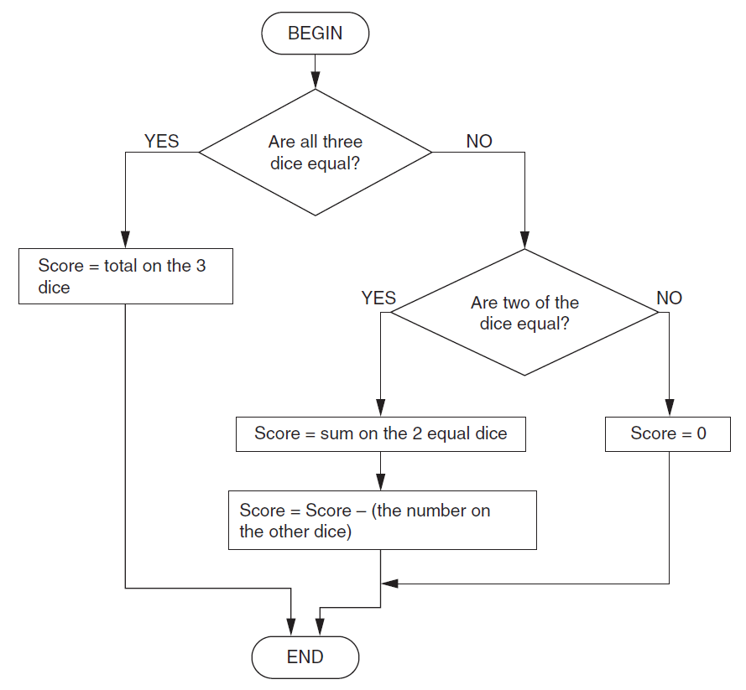
  - When the player rolls the three dice, the player is given points according to the algorithm expressed in the flow diagram (flow chart) below.
State the value of the score if the dice rolled are
3 4 5 Score:
4 4 4 Score:
5 5 6 Score:
  - Some rolls of the dice result in a negative score.
State a set of three numbers which can be used to test whether the algorithm produces a negative score when it should, and state the expected output for your test data.
Set of test data:
Expected output:
  - When the dice are rolled, the results are stored in an array called DiceResult.
For example, if the first dice shows a 5 then the value of DiceResult(1) becomes 5.
Describe what is meant by an array.
  - State the data type and size of the array DiceResult giving a reason for each.
  - The routine for rolling the dice is written as a sequence below.
BEGIN RollTheDice
DiceResult(1) = Random Number between 1 and 6
DiceResult(2) = Random Number between 1 and 6
DiceResult(3) = Random Number between 1 and 6
END
Rewrite this routine so that it uses iteration.
You may use a diagram.
- A mail-order company buys dresses from America and France to sell in the UK.
The company uses the following algorithm to convert sizes before printing them in its catalogue. Half sizes are not possible (e.g. size 12.5).
INPUT Size
INPUT Origin
IF Origin = “America” THEN
Size = Size + 2
ELSE
IF Origin = “France” THEN
Size = Size – 26
END IF
END IF
PRINT Size
  - The code uses the variables Origin and Size.
    - Describe what is meant by a variable.
    - State the most appropriate data types for the variables Origin and Size, giving a reason for your choice.
  - The company sells the following dresses.
Dress A Dress B Dress C
Origin : France Origin : America Origin : UK
Size : 40 Size : 8 Size : 12
State the size which will be printed in the catalogue using the algorithm given for each of the dresses.
- The program in a vending machine uses an array called Coins to store the value in pence of all the coins that have been entered in the current sale.
A maximum of 10 coins can be entered in each sale.
After each sale, the array is reset so that all values are 0.
  - Here is an example of the contents of the array Coins during a sale.
In the example above, the value of Coins(1) is 10.
State the value of
Coins(4)
Coins(10)
  - An algorithm to reset the contents of the array Coins after each sale is shown below. This algorithm contains a logic error.
i = 1
REPEAT
Coins(i) = 0
i = i + 1
UNTIL i = 10
    - State what is meant by a logic error.
    - Explain why the algorithm above contains a logic error.
  - Write an algorithm to calculate the total value of the coins entered in the current sale using the contents of the array Coins.
- A program contains the following code to calculate the circumference of a bicycle wheel, using the wheel size (diameter).
BEGIN
CONSTANT Pi = 3.14
INPUT WheelSize
Circumference = Pi * WheelSize
OUTPUT Circumference
END
  - The code uses one constant and two variables.
    - State the name of the constant.
    - State the names of the two variables.
    - Explain one difference between a constant and a variable.
  - The data type of WheelSize is integer and the data type of Circumference is real number.
Explain the difference between an integer and a real number.
- A dog that is 5 years old is equivalent to a 42 year old human. Kyle is writing a program which converts the age of a dog to the equivalent age for a human.
The program uses the following method:
• The user inputs age of the dog in years.
• If the age is 2 or less, the human equivalent is 12 times the age.
• If the age is more than 2, the human equivalent is 24 for the
first 2 years, plus 6 for every additional year.
Write an algorithm to calculate and output the human equivalent of the age of a dog using the method described.
- A program includes the following code.
If A > B Then
A = B
B = A
End If
  - The code uses the variables A and B. Describe what is meant by a variable.
  - State the final values of the variables A and B if the values at the beginning of the code are
    - A=4, B=9
    - A=6, B=2
  - The intention of lines 02 and 03 is to swap the contents of the variables A and B. This does not work. Rewrite the code so that the contents of the variables are swapped correctly.
- A display board can show a flashing message of up to 20 characters.
  - A program allows users to input the message to be displayed and the number of times it should flash.
State the data type of each item of the input data.
Message:
Number of flashes:
  - Write an algorithm for the program which:
•Allows the user to input the message and the number of flashes.
•Rejects the message if it is longer than 20 characters and stops.
•Otherwise it repeatedly displays the message and clears the display
for the correct number of times.
- Crystal has a program (app) on her mobile phone, which calculates the cost of the calls she has made.
  - The program uses the following variables.
State the most appropriate data type for each variable.
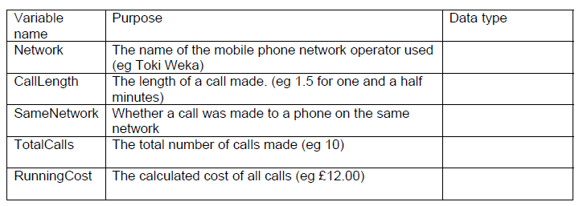
  - The algorithm to update the data when a new text call is made is shown below.
PROCEDURE Update
TotalCalls = TotalCalls + 1
IF SameNetwork = TRUE THEN
RunningCost = RunningCost + 0.01
ELSE
RunningCost = RunningCost + (CallLength * 0.10)
END IF
END PROCEDURE Update
So far TotalCalls = 10 and RunningCost = £12.00
    - Crystal makes a 3 minute call to a phone on the same network.
State the values of TotalCalls and RunningCost after they have been updated using this algorithm.
    - Crystal now makes a 5 minute call to a phone on a different network.
State the values of TotalCalls and RunningCost after they have been updated using this algorithm.
- Josh is writing a program to convert the time from the 24 hour clock to the 12 hour clock.
Here is an extract from his program. This extract contains two errors.
IF (hours > 12) ADN (hours < 24) THEN
hours = hours + 12
END IF
  - Explain why there is an error in the first line, and state what type of error this is.
  - Explain why there is an error in the second line, and state what type of error this is.
- Felix is writing a program that uses an array called WordList. This array contains 10 foreign words in alphabetical order. The contents of the array are shown below.
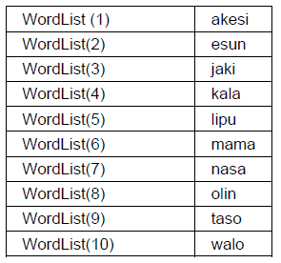
  - The value of WordList(1) is “akesi”.
Complete the following statements.
    - The value of WordList(6) is .....................
    - The value of WordList(.............................) is “taso”
  - Felix needs to write a routine that:
•allows the user to input a word,
•goes through the items in the array WordList in turn, starting from
the WordList(1),
•if it finds the word that the user has input, it outputs “Word
found”.
Write down an algorithm for this routine in pseudocode.

  - Explain why a program written in a high level language needs to be translated before it can be executed.
  - A compiler and an interpreter are two different types of translator. Describe one difference between a compiler and an interpreter.

