  - Convert the denary number 106 into an 8 bit binary number. (2)
  - Convert the denary number 106 into hexadecimal. (2)
- Peter takes a high resolution picture with a digital camera. The picture is stored in a bitmap file.
  - Describe how a picture is stored in a bitmap file. (3)
  - Peter wants to send the picture as an email attachment. State two methods for reducing the size of the picture file so that it is suitable for sending as an email. (4)
- Data stored in computers can be measured in bits, bytes and kilobytes.
  - State what is meant by
    - A bit (1)
    - A byte (1)
  - A file contains 5120 bytes. Calculate the size of the file in kilobytes. You must show your working. (2)
- An artist is recording sound using a computer. The graph below represents the pressure wave of the sound being recorded.
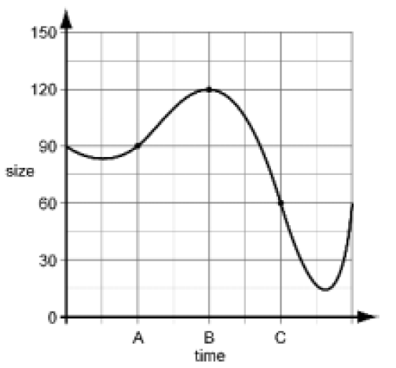
  - At point A on the graph, the size of the sound wave is 90. This is stored digitally using the binary value of 0101 1010 (or 5A in Hex). Complete the table below to show how points B and C are stored: (6)
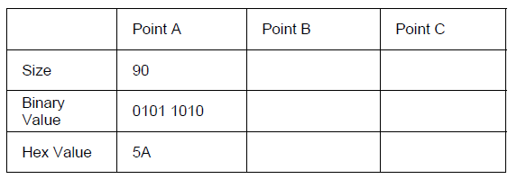
  - Explain how sampling intervals and compression can affect the size of a sound file and the quality of its playback. The quality of your written communication will be assessed in your answer to this question. (6)

  - Calculate the denary value of the 8-bit binary number 10010111. You must show your working. (1)
  - Add the following two 8-bit binary numbers and explain the result. You must show your working. (3)
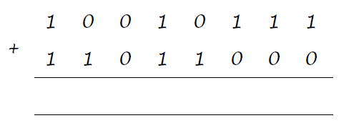

  - Explain how ASCII is used to represent text in a computer system. (2)
  - State what is meant by the character set of a computer. (1)
  - Unicode is also used to represent text in a computer system. Explain the difference between the character sets of Unicode and ASCII. (2)
- Describe the difference between lossy and lossless compression and give an example where each would be used. (4)

  - Convert the hexadecimal number 6A to denary. You must show your working. (2)
  - Convert the hexadecimal number 6A to binary. (2)
  - Convert the binary number 00111101 to hexadecimal. (2)
  - Explain why hexadecimal numbers are often used to represent binary numbers. (2)
- Bytes, Kilobytes and Megabytes are units used for the amount of data stored in a computer.
  - State which of these units is most appropriate for the following items of data. (3)
    - A one page text document
    - A ten minute movie clip
    - A person’s surname
  - A computer has a hard disk of 2 Terabytes. How much is this in Gigabytes? You must show your working. (2)
- Peter takes a picture of himself and his friends to put on a social networking site. The picture is converted into pixels and stored as a bitmap file.
  - Tick one box in each row to show whether or not each of the following items must be included in the bitmap file. (5)
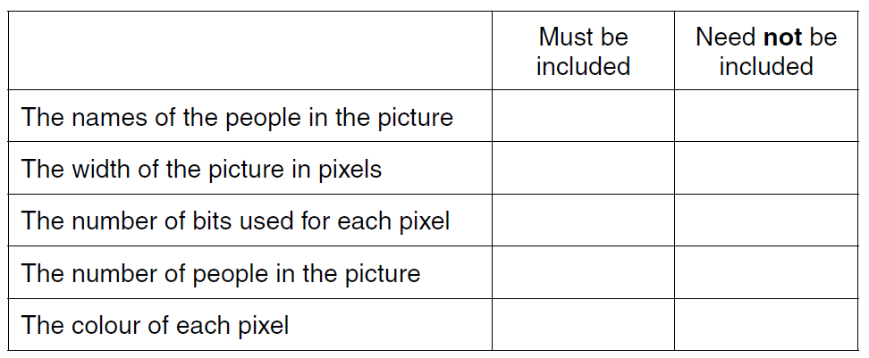
  - What is meant by the resolution of the picture? (1)
  - How does the resolution affect the size of the bitmap file? (2)

