End of Unit Test – Networking

- The following table contains statements about computer networks.
Tick one box in each row to show whether each statement is true or false.
 | True | False
A standalone computer is one that is connected to a network, but not to the Internet |  | x
A standalone computer is more secure than a networked computer. | x
The Internet is an example of a Wide Area Network | x
[3]
- A user types the address www.ocr.org.uk into a web browser.
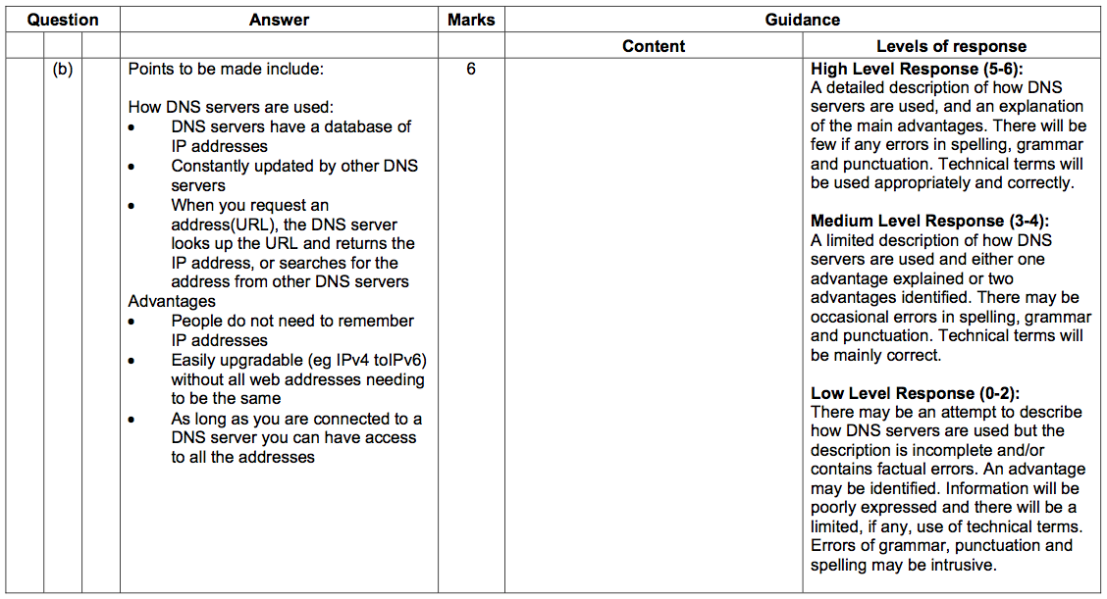
Describe how a DNS server is used to access this website and explain the advantages of using DNS servers.
The quality of written communication will be assessed in this question. [6]
- Xavier has been asked to set up a LAN for a local travel agent’s office.
- What does LAN stand for?
…Local Area Network………………………………………………………………………………
[1]
- Once completed, users on the network will be able to share files.
State two other things that could be shared over the network and explain how each will help the company.

Shared: …Printer…………………………………………………………………………
Benefit: ……Only 1 printer needed for the whole office, not one per machine – so cheaper…………………………………………

Shared: …Internet connection…………………………………………………
Benefit: …All workstations can access the Internet at the same time
[4]

- State which piece of hardware is required for each computer that will be connected to the network.
…Network Interface Card (or NIC)………………………………………………………
[1]

- One of Xavier’s colleagues has suggested he connect the computers using a bus network. Complete the diagram below to show how the network might be connected.
Computer 2
Computer 1
Computer 4
File Server
Computer 3
[2]
- A different colleague suggested that a star network might me more appropriate. Complete the diagram below to show how the network might be connected.
All computers and server connected
Each node connected to exactly 2 others
[3]

Hub / Router / Switch

Computer 3
File Server
Computer 4
Computer 2
Computer 1

All nodes connected
Each node connected to 1 device
Routing device OR server used as the central device

- Give 1 advantage for choosing each type of network.
Ring network:
…Cheap / Easy to set up / Less cabling / No extra devices needed……
Star network:
…More reliable (if one node goes down) / Copes better with a busier network / More secure (if qualified – routers/switches only broadcast to the destination)
[2]
- The following table contains statements about computer networks.
Tick each at least one box in each row to show whether each statement is true for LANs or WANs. Some statements may be true for both.
 | LAN | WAN
A type of network suitable for computers on one site | X
A type of network that uses existing telecommuncations infrastructure for communication |  | X
A type of network that allows users to share a printer | x | X
A network that supports client-server relationships | x | X
A network that requires the use of a modem |  | X
[5]
- Some download services use peer-to-peer networking.
Describe how a peer-to-peer network functions and why it might be preferable to the client-server model for sharing large files.
The quality of written communication will be assessed in this question. [6]
See DNS example. Points to be made include data split into small pieces, any machine with any piece can share with any other. Reduces load on the originating server. Increases load on other machines (what would be clients). Less reliance on one central sever – if that goes down the files can still be shared. Some people will download and then not continue to share (leeching). Users may be able to download more quickly because the main server will be less busy and routes to other peers may be quicker.

- Give two advantages and one disadvantage for using a bus network instead of a ring network.
Advantage: …More reliable (e.g. if one machine goes down)…….……
Advantage: …Copes better with more traffic/busier network..…
Easier to add/remove nodes
Disadvantage: …More cabling / more equipment / reliance on central bus…
[3]
- Match the following diagrams to the network type.

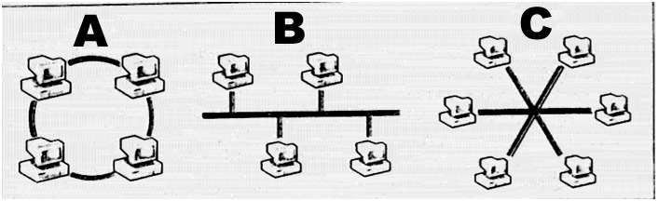

Network Type | Letter
Bus Network | B
Ring Network | A
Star Network | C
[3]

